Objective: Describe the basic construction of building components

Materials Needed: Digital Camera (Camera Phone), Computer, Internet Access

Define the following:

Type 1: _____________________________________________________________________________________

Type 2:
_____________________________________________________________________________________

Type 3:
_____________________________________________________________________________________

Type 4:
_____________________________________________________________________________________

Type 5:
_____________________________________________________________________________________

My residence is a Type ___________________ construction.

Define Foundation: _____________________________________________________________________
_____________________________________________________________________________________

Define Footing: ________________________________________________________________________

Describe the difference between a shallow foundation and a deep foundation: _____________________________________________________________________________________
_____________________________________________________________________________________
_____________________________________________________________________________________

Describe your residences foundation: _____________________________________________________________________________________
_____________________________________________________________________________________
_____________________________________________________________________________________

Floors and Ceilings: (refer to page 159 for definitions)
What is the construction of your ground-level floor? __________________________________________
What is the construction of your ceiling? ___________________________________________________
What is the construction of the second floor (if applicable)? ____________________________________

Wall:
Sketch out the Ground Floor Floor-Plan. DEFINE and LABEL the following:
- Load-Bearing Walls: ______________________________________________________________
- Non-Loadbearing walls / Partition Walls / Curtain Walls : ________________________________ ______________________________________________________________________________
- Fire Walls (if applicable) __________________________________________________________
______________________________________________________________________________
- Party wall (if applicable) __________________________________________________________
______________________________________________________________________________

LABEL THE FOLLOWING ROOF TYPES
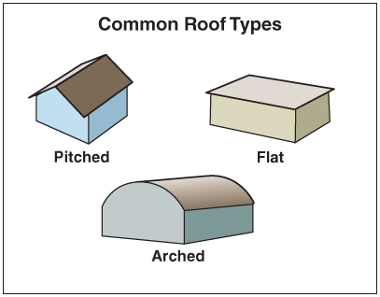

Flat Roofs:
What type of structures are they commonly found: _____________________________________________________________________________________
What commonly surrounds a flat roof:
_____________________________________________________________________________________
Define parapet:
_____________________________________________________________________________________

Pitched Roofs:
Define ridge:
_____________________________________________________________________________________
Define eave:
_____________________________________________________________________________________
What runs from the ridge line to the outer wall at the eaves level:
_____________________________________________________________________________________
Define decking:
_____________________________________________________________________________________
Describe how a pitched roof is finished:
_____________________________________________________________________________________
_____________________________________________________________________________________

The roof of my residence is: _____________________________________________________________
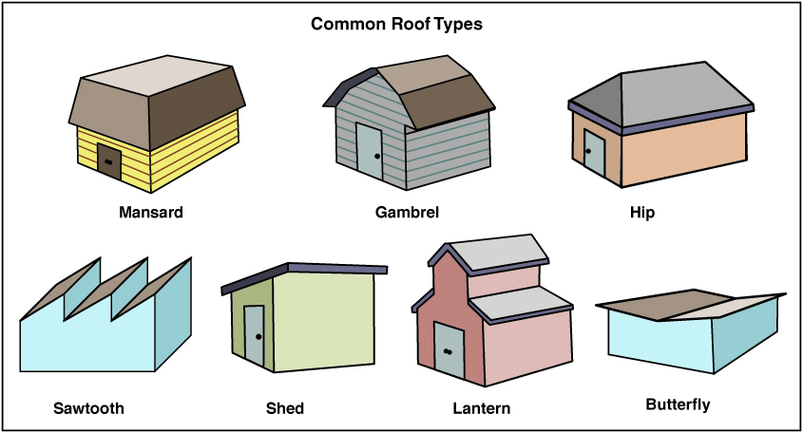

Arched Roofs:
The design of the arched roof depends primarily: _____________________________________________ __________________________________________________________________________________________________________________________________________________________________________

Draw the four types of Arched Roof Designs:
Ribbed, Barrel, Lamella and Bowstring

Roof Supports:

Explain the difference between beam and truss assemblies: ____________________________________
__________________________________________________________________________________________________________________________________________________________________________
_______________________________________________________________________________________________________________________________________________________________________________________________________________________________________________________________
_____________________________________________________________________________________
Define gusset plate: ____________________________________________________________________ _____________________________________________________________________________________

Draw the roofline of your structure: If possible, determine whether it is beam or truss assembly.

What is the roof covering made from? ________________________________________

List the penetrations in the roof, if visible and safe to do so:

Stairs:
What is a means of egress?______________________________________________________________

Label types of stair designs:

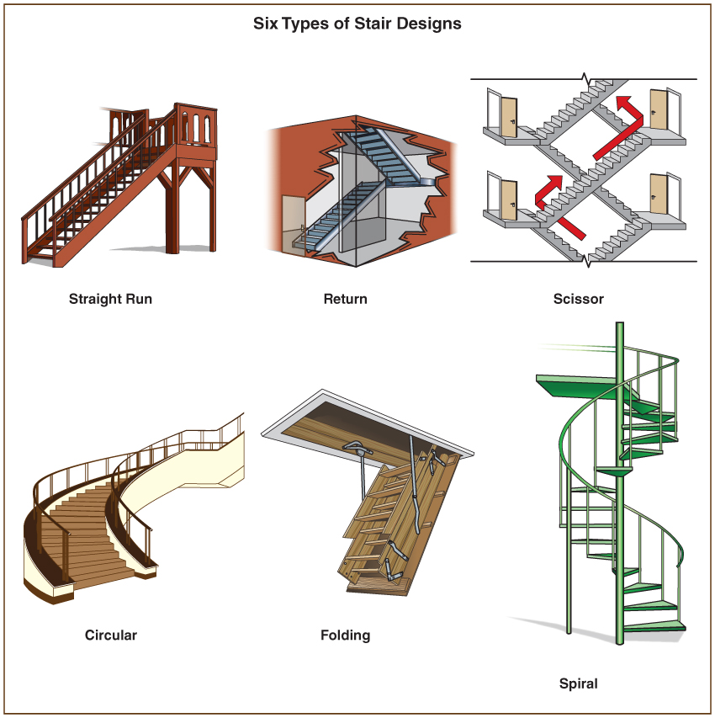

What are Protected Stairs: __________________________________________________________________________________________________________________________________________________________________________

What are Fire Escapes:
__________________________________________________________________________________________________________________________________________________________________________
What are Smoke Proof Stair Enclosures:
_____________________________________________________________________________________
_____________________________________________________________________________________

What are Unprotected Stairs:
__________________________________________________________________________________________________________________________________________________________________________

What type of Stairs do you have in your residence (if any):
__________________________________________________________________________________________________________________________________________________________________________

Doors:
Define the following
- Swinging ______________________________________________________________________________
- Sliding ______________________________________________________________________________
- Folding
______________________________________________________________________________
- Vertical
______________________________________________________________________________
- Revolving
______________________________________________________________________________
Circle the types of doors you have in your residence.

Describe the differences between a panel, solid core and hollow core door.
____________________________________________________________________________________________________________________________________________________________________________________________________________________________________________________________________________________________________________________________________________________

Windows:
Draw a window in your residence and label the parts. (Use

LABEL THE FOLLOWING TYPES OF MOVABLE WINDOWS – Circle the ones that may be in your residence.
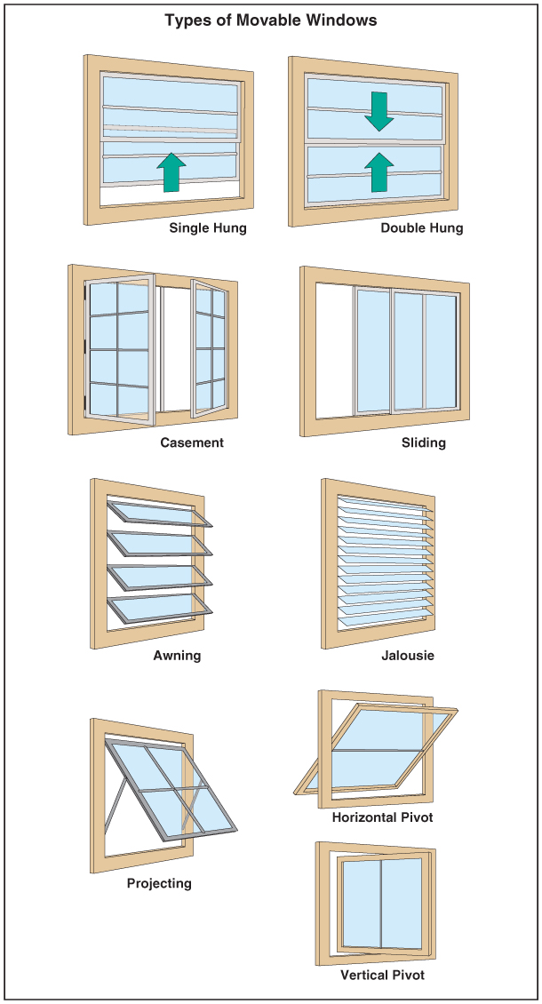

Reading from page 190, write what an incident commander might say about your residence on the initial size-up?
____________________________________________________________________________________________________________________________________________________________________________________________________________________________________________________________________________________________________________________________________________________
____________________________________________________________________________________________________________________________________________________________________________________________________________________________________________________________________________________________________________________________________________________

Regarding your type of residence, what structural collapse factors may come into play if you’ve had a fire burning, unreported for 20 minutes in the kitchen of your residence?

____________________________________________________________________________________________________________________________________________________________________________________________________________________________________________________________________________________________________________________________________________________
____________________________________________________________________________________________________________________________________________________________________________________________________________________________________________________________________________________________________________________________________________________
____________________________________________________________________________________________________________________________________________________________________________________________________________________________________________________________________________________________________________________________________________________
____________________________________________________________________________________________________________________________________________________________________________________________________________________________________________________________________________________________________________________________________________________
____________________________________________________________________________________________________________________________________________________________________________________________________________________________________________________________________________________________________________________________________________________
____________________________________________________________________________________________________________________________________________________________________________________________________________________________________________________________________________________________________________________________________________________

